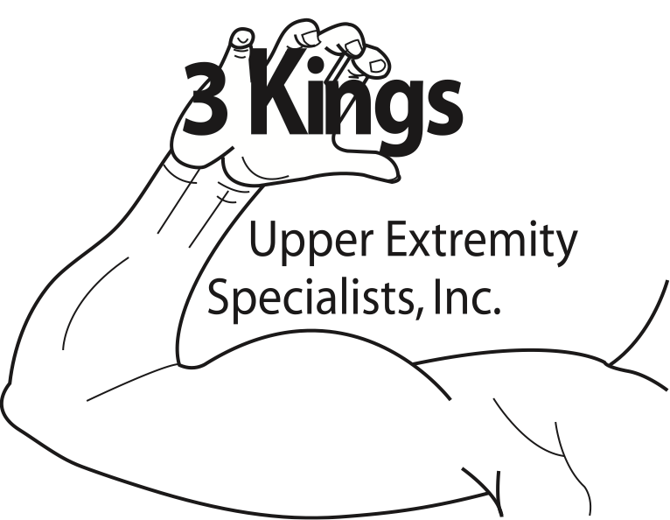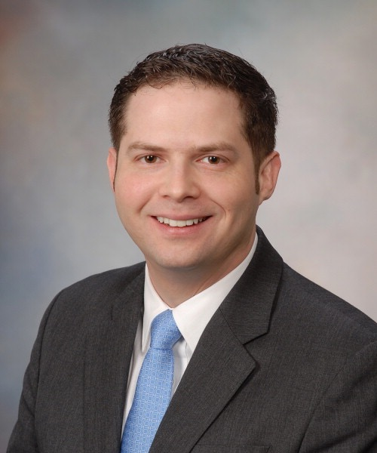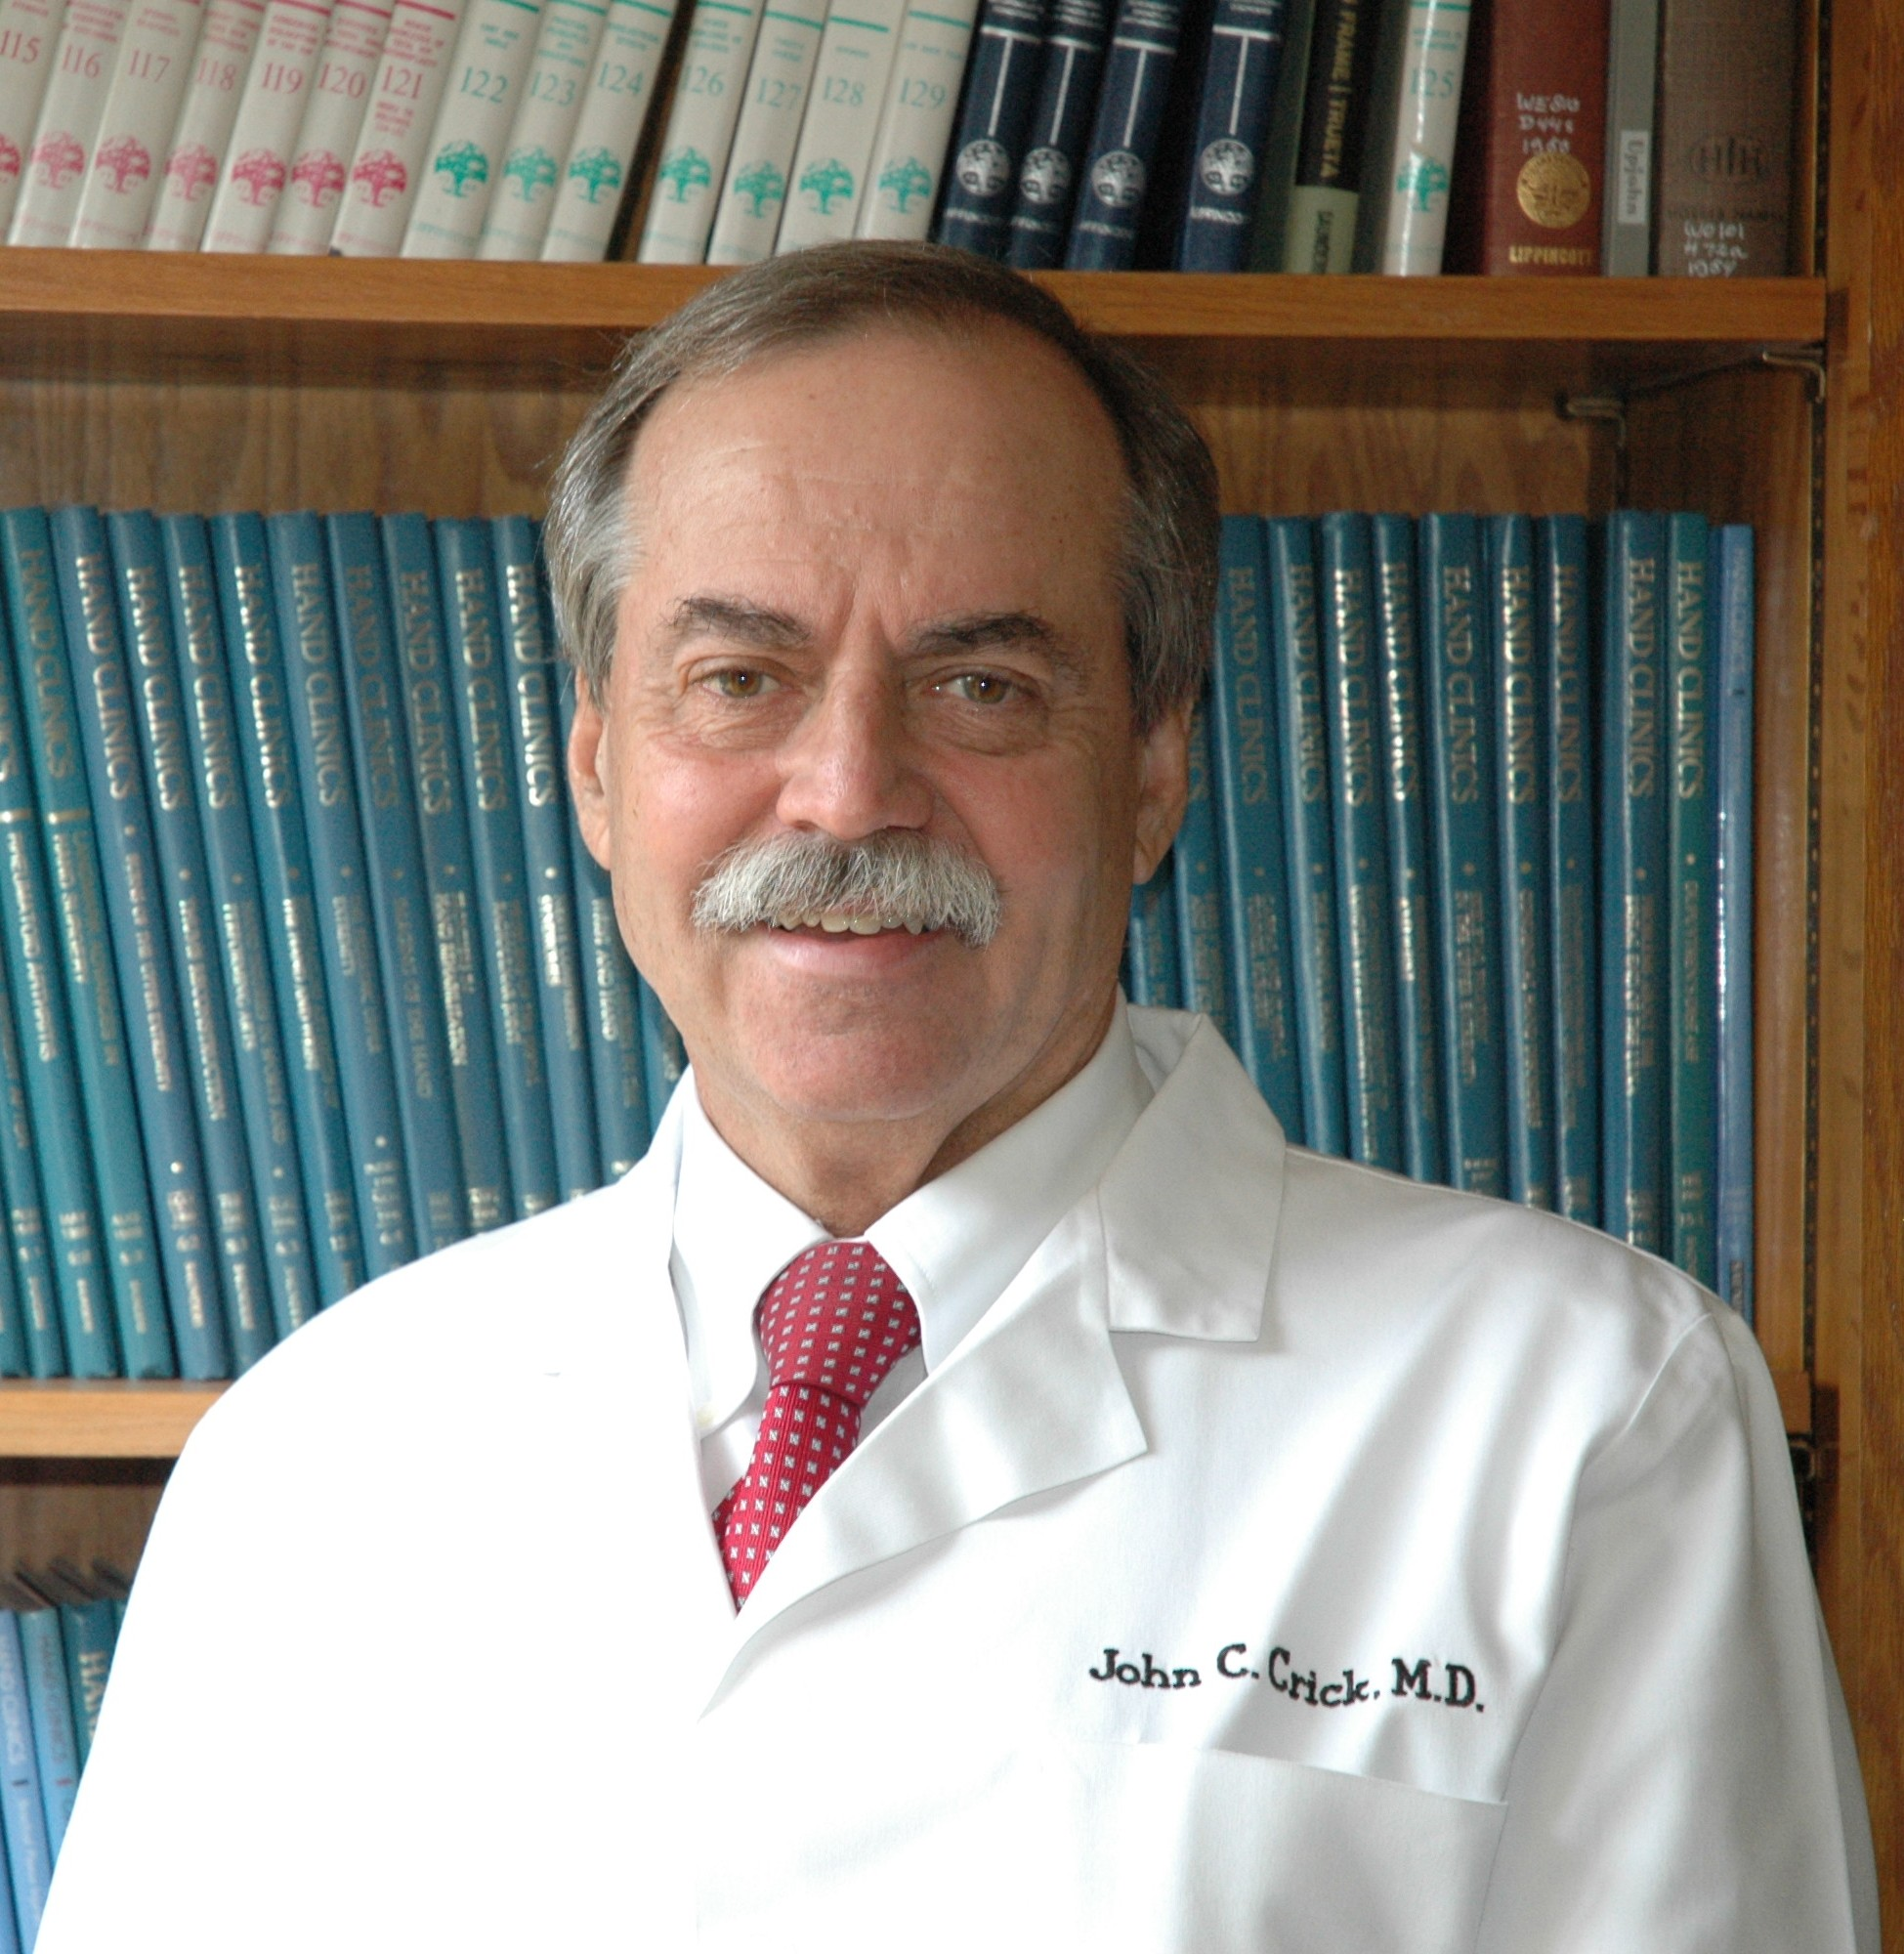

**COURSE COST:**

$210 if you have not attended a previous course

$189 if you have attended a previous course

$25 for students or other healthcare professionals (Non OT/PT)-limited spots, please contact

*Pay Pal: There will be a $10 charge to pay via credit card on PayPal. Please use [3KingsUEspecialist@gmail.com](mailto:3KingsUEspecialist@gmail.com) for payment on PayPal

*Costs includes dinner Friday evening, coffee and snacks Saturday morning

\***Handouts will be emailed to participants prior to course to be printed out and brought to the course**

**CANCELLATION POLICY:**

Due to small class size, there will be NO refunds if cancellation received on or after May 07, 2018. If you are able to find someone to take your place, that person can pay you directly so that that you will receive a full refund. You will just need to contact me to let me know the name of the person taking your place. **3Kings UE Specialists will not refund any expenses associated with travel expenses or fees for registering online, only course costs.**

**CONTINUING EDUCATION CREDIT:**

**7.8 contact hours**

*PTs/PTAs and ATCs will have to submit this course individually for approval (This can also be done prior to the course. Cost is $20 payable to the FL Board of PT). 3Kings UE Specialists will provide documentation needed to submit the course.

*Out of state therapists please contact your board for approval

*Other healthcare professionals will be responsible for submitting to their state board for approval

*3Kings Upper Extremity Specialists will provide CEUs to Florida and Alabama OT/OTAs

**2018 Jacksonville Upper Extremity Conference**

May 11-12, 2018

**Location: Montreux at Deerwood Lakes**

**Theater Room**

**8550 Touchton Rd.**

**Jacksonville, FL 32216**

**Times: Friday, May 11: 5:30-9pm**

**Saturday, May 12: 8-noon**

**Targeted Audience: OT/OTAs, PT/PTAs, ATCs of all experience levels**

**Contact Hours: 7.8**

**Cost: $210 if you have not attended a previous course, $189 if you have attended a course**

**PAYMENT COUPON**

Name:______________________________________

Address:____________________________________

___________________________________________

___________________________________________

Phone:____________________________________

Email:_____________________________________

Profession:(Circle) OT OTA PT PTA

Student Other

License number:____________________________

Employer:__________________________________

Amount: (Circle) $210 $189

**Make checks payable to 3Kings Upper Extremity Specialists and mail to:**

**56 Solana Rd**

**Ponte Vedra Beach, FL 32082**

Please contact Jennifer Dodson OTR/L,CHT at

904-803-4480 or [3KingsUEspecialist@gmail.com](mailto:3KingsUEspecialist@gmail.com) with any questions. Visit [www.3KingsUEspecialists.com](http://www.3kingsuespecialists.com) or 3Kings Upper Extremity Specialists Facebook page

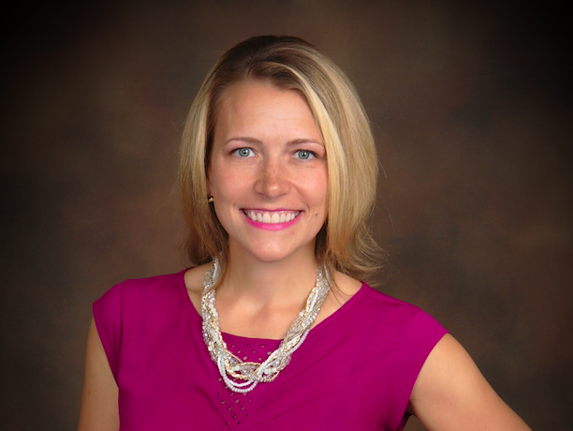

**John Crick Beverly Bass Antonio Forte**

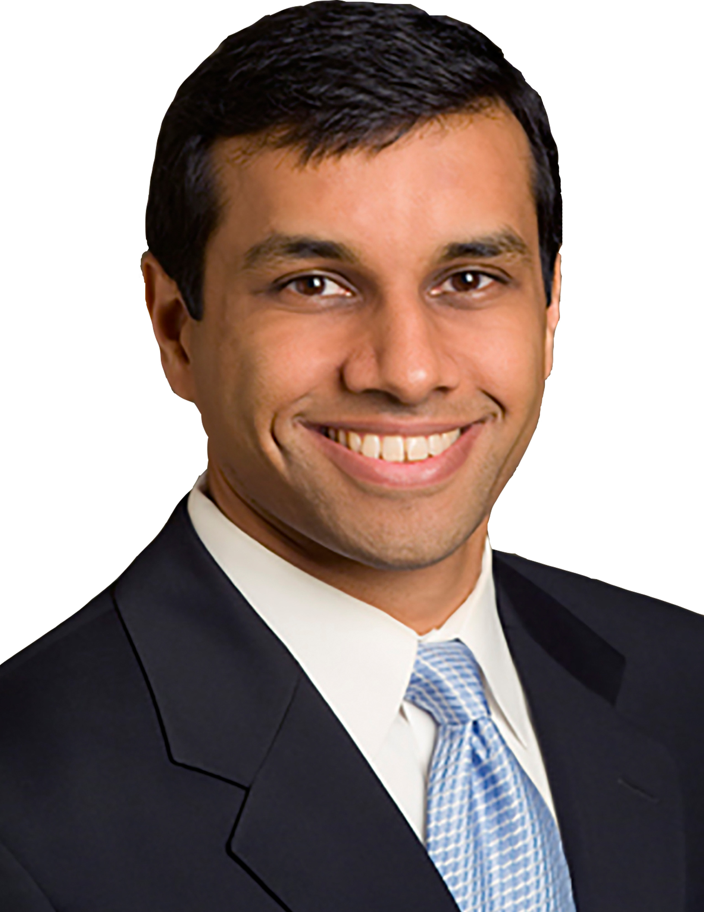 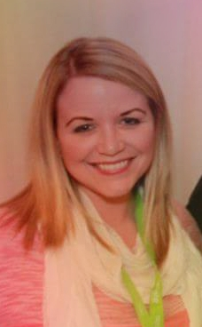 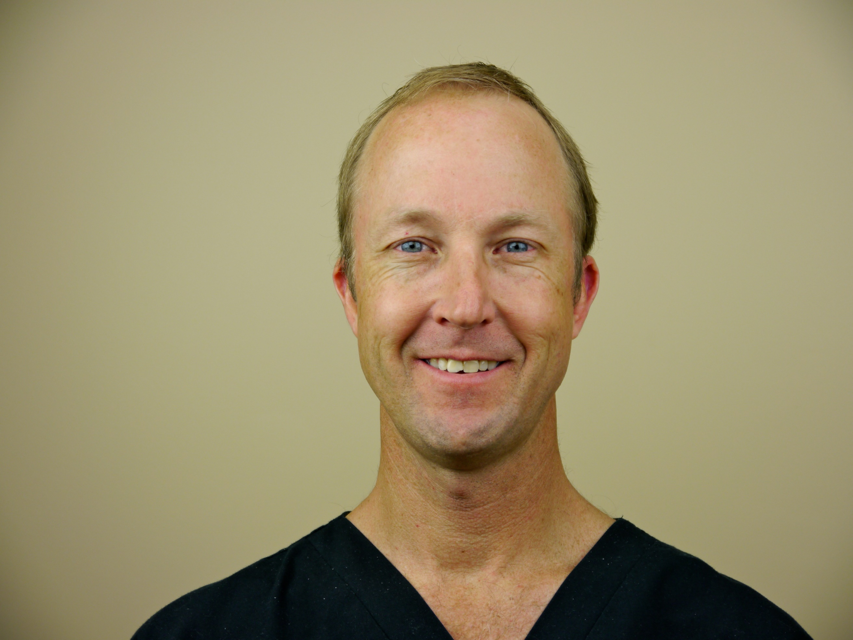

**Rahul Deshmuhk Melinda Petty Chris Kopp**

**Full biographies on the website**

**Beverly Bass OTD, OTR/L, CHT, CLT:** University of St. Augustine, UF Health Jacksonville, Select Physical Therapy

**John Crick, MD:** Bahri Orthopedics and Sports Medicine

**Rahul Deshmuhk, MD:** Southeast Orthopedics (not pictured)

**Antonio Forte, MD, MHS, PhD:** Mayo Clinic Jacksonville

**Chris Kopp, PT, OCS, CMPT:** Premier Physical Therapy

**Melinda Petty DPT,OTR/L,CHT:** UF Health Jacksonville

**AGENDA:**

**Friday, May 11:**

*5:30-545pm: Registration

*5:45-6:15: Antonio Forte, MD, MHS, PhD: "Microsurgical treatment of UE lymphedema”

*6:15-6:30-Get dinner and return to seats

*6:30-7:30-Beverly Bass, OTD, OTR/L, CHT, CLT: Lymphedema techniques in the orthopedic population(Lecture followed by lab)

*7:30-8:30-Melinda Petty DPT,

OTR/L,CHT: "Cervical Spine screening”-(Lecture followed by lab)

8:30-8:45: Closing

**Saturday, May 12:**

*8-8:15 am: Registration

*8:15-8:45: Rahul Deshmukh, MD: “Work up, evaluation and treatment of common shoulder problems”

*8:45-9:30: John Crick, MD: "Peripheral nerve injuries and nerve transfers”

*9:30-9:45: Break

*9:45-11:45: Chris Kopp PT,OCS,CMPT-“Kinematic taping for the shoulder and UE including the brachial plexus”(Lecture and lab)

*11:45-noon: Closing and final evaluations

**Course objectives**

1. Participants will become familiar with surgical techniques for treatment of upper extremity lymphedema
2. Participants will become familiar with lymphedema techniques to utilize in the orthopedic population
3. Participants will become familiar with surgical options for peripheral nerve injuries and nerve transfers
4. Participants will be able to practice techniques to perform cervical spine screening and taping for the shoulder and brachial plexus